**How to create git hub project and use it in the DevOps Pipeline:**

Once the project is created in Eclsipe, click the project top level and right click ->Team -> Share Project

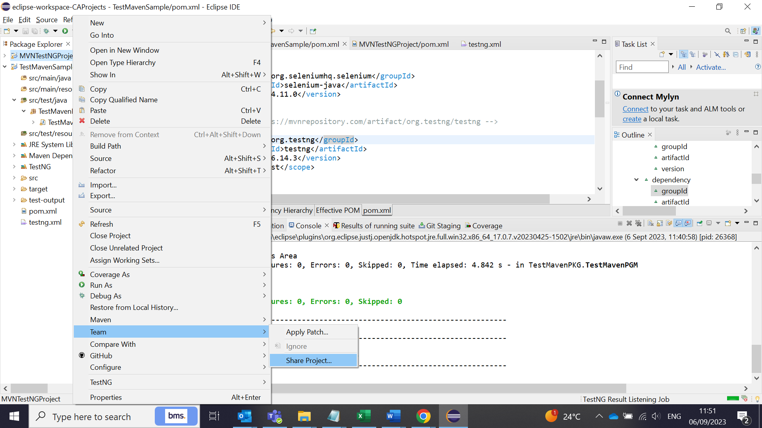

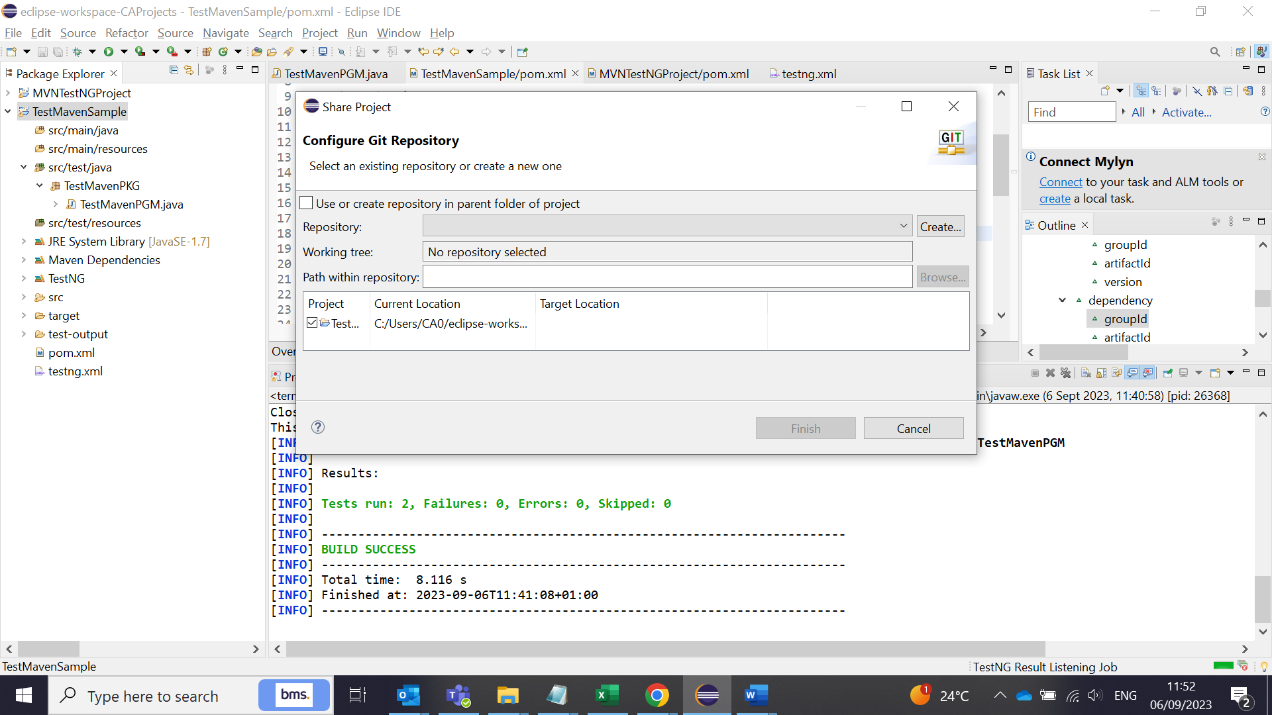

Click the checkboxes and open the dialog box as follows:

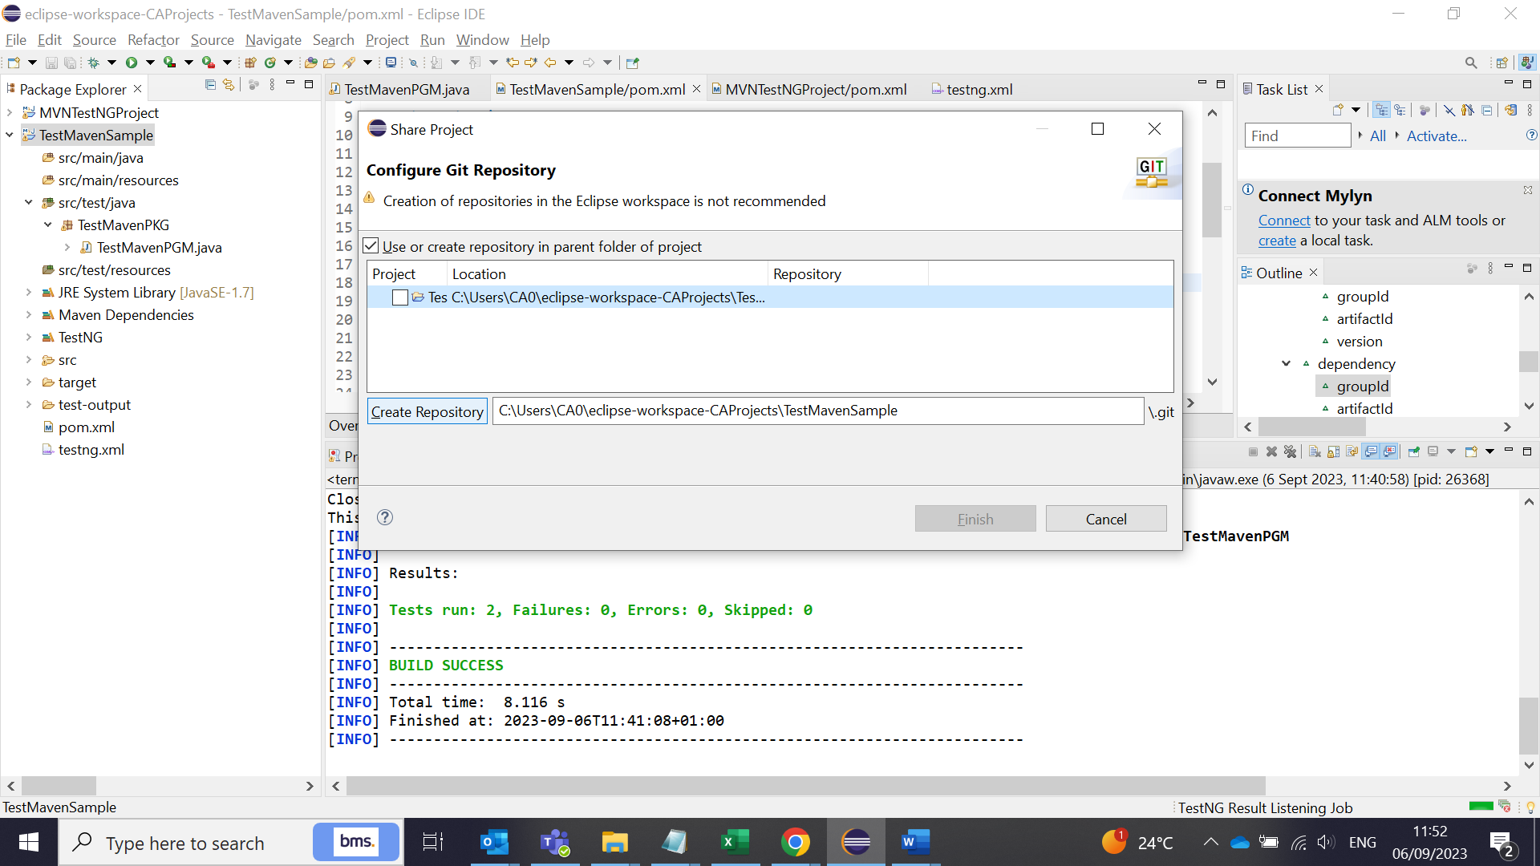

Click create repository button:

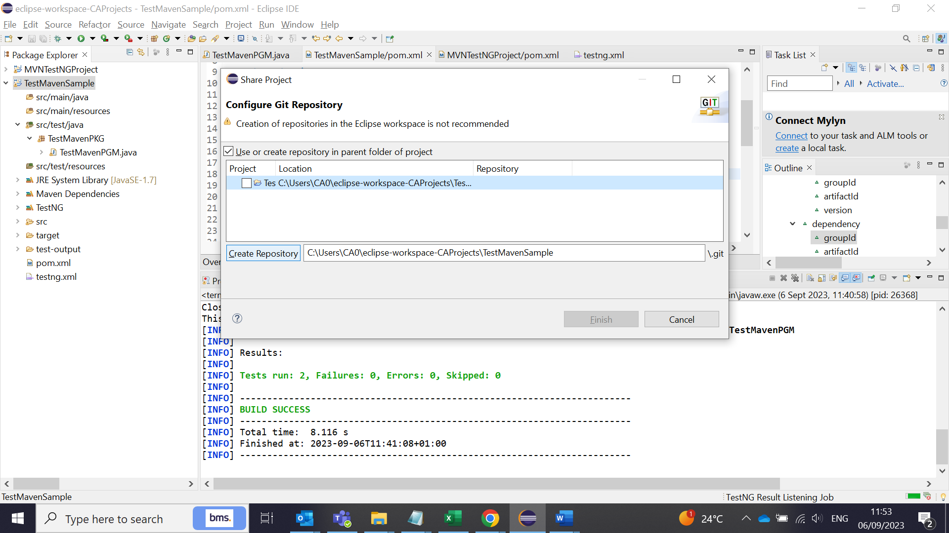

Now, .git repository created next to the folder path:

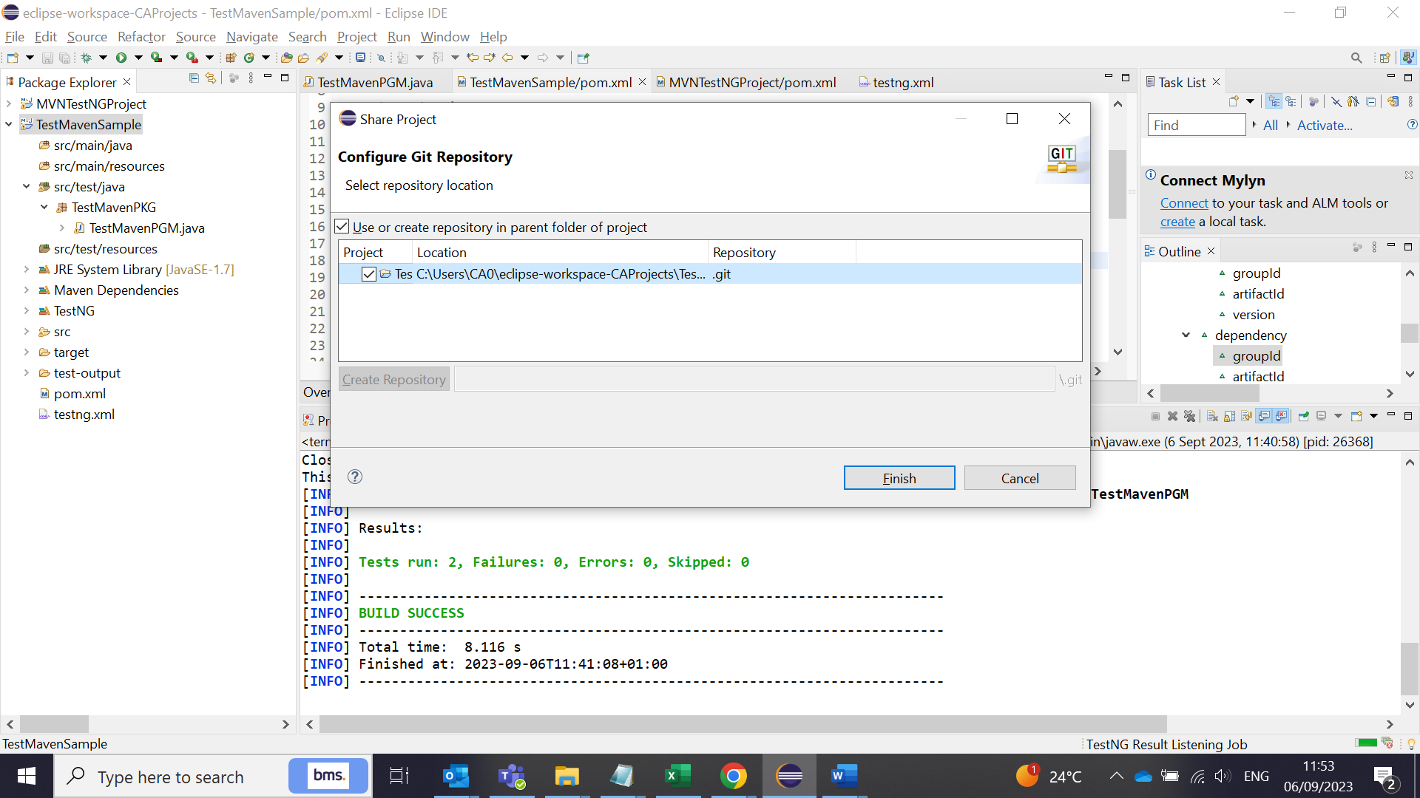

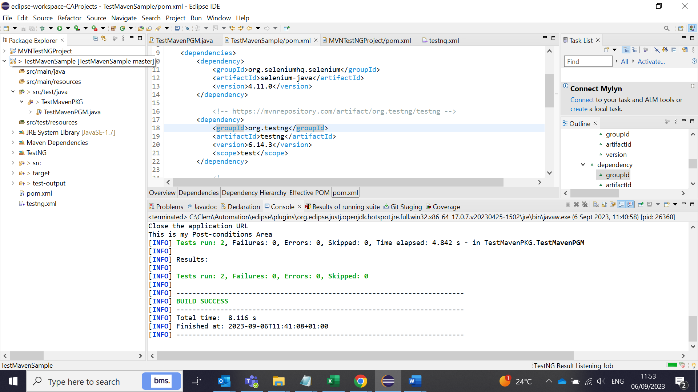

To push the project in to Git repository, click commit and then in the Git staging window, select all the files from the unstagged window and then drag and drop to the stagged widnow.

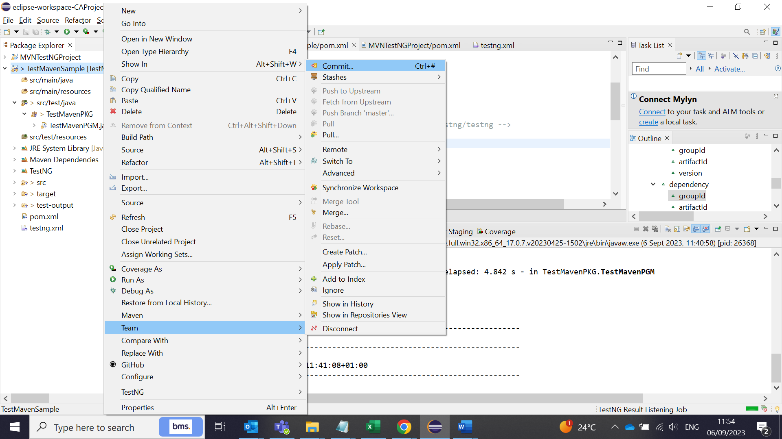



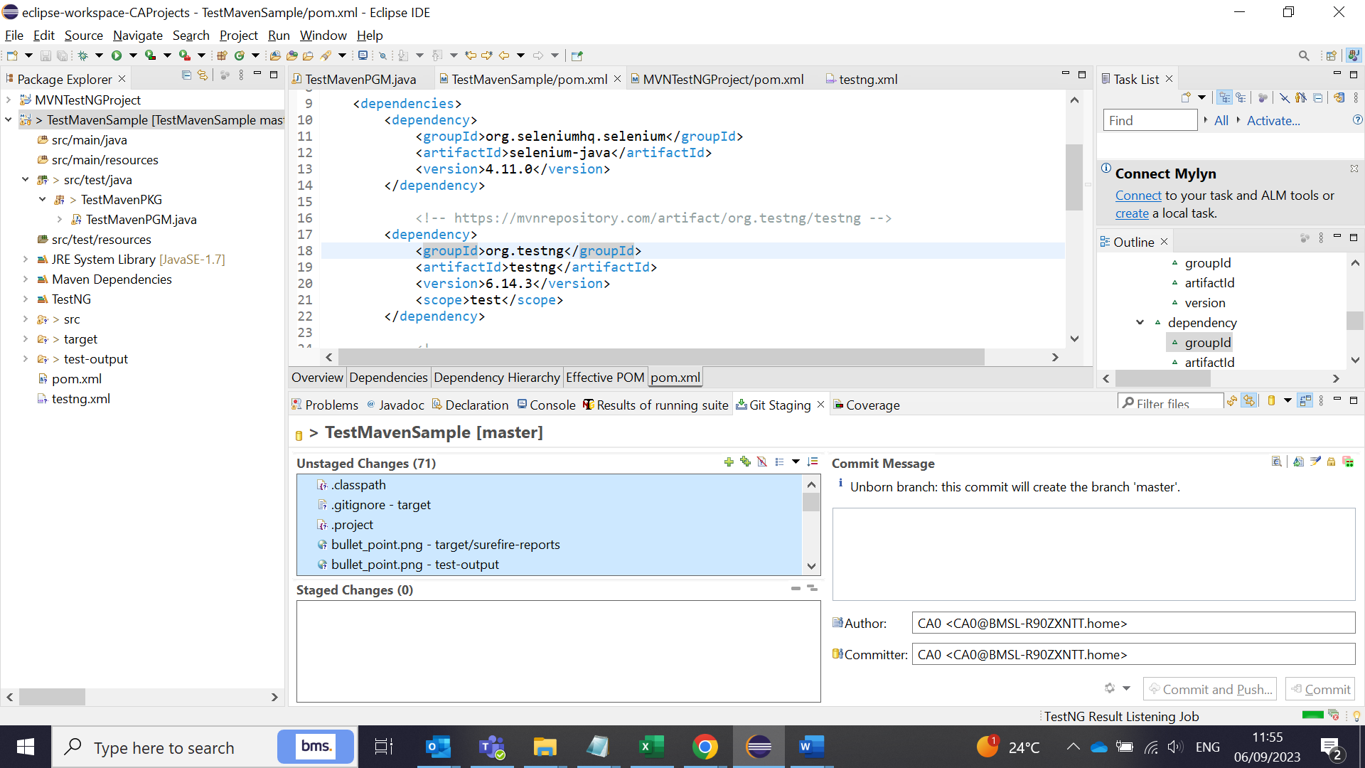

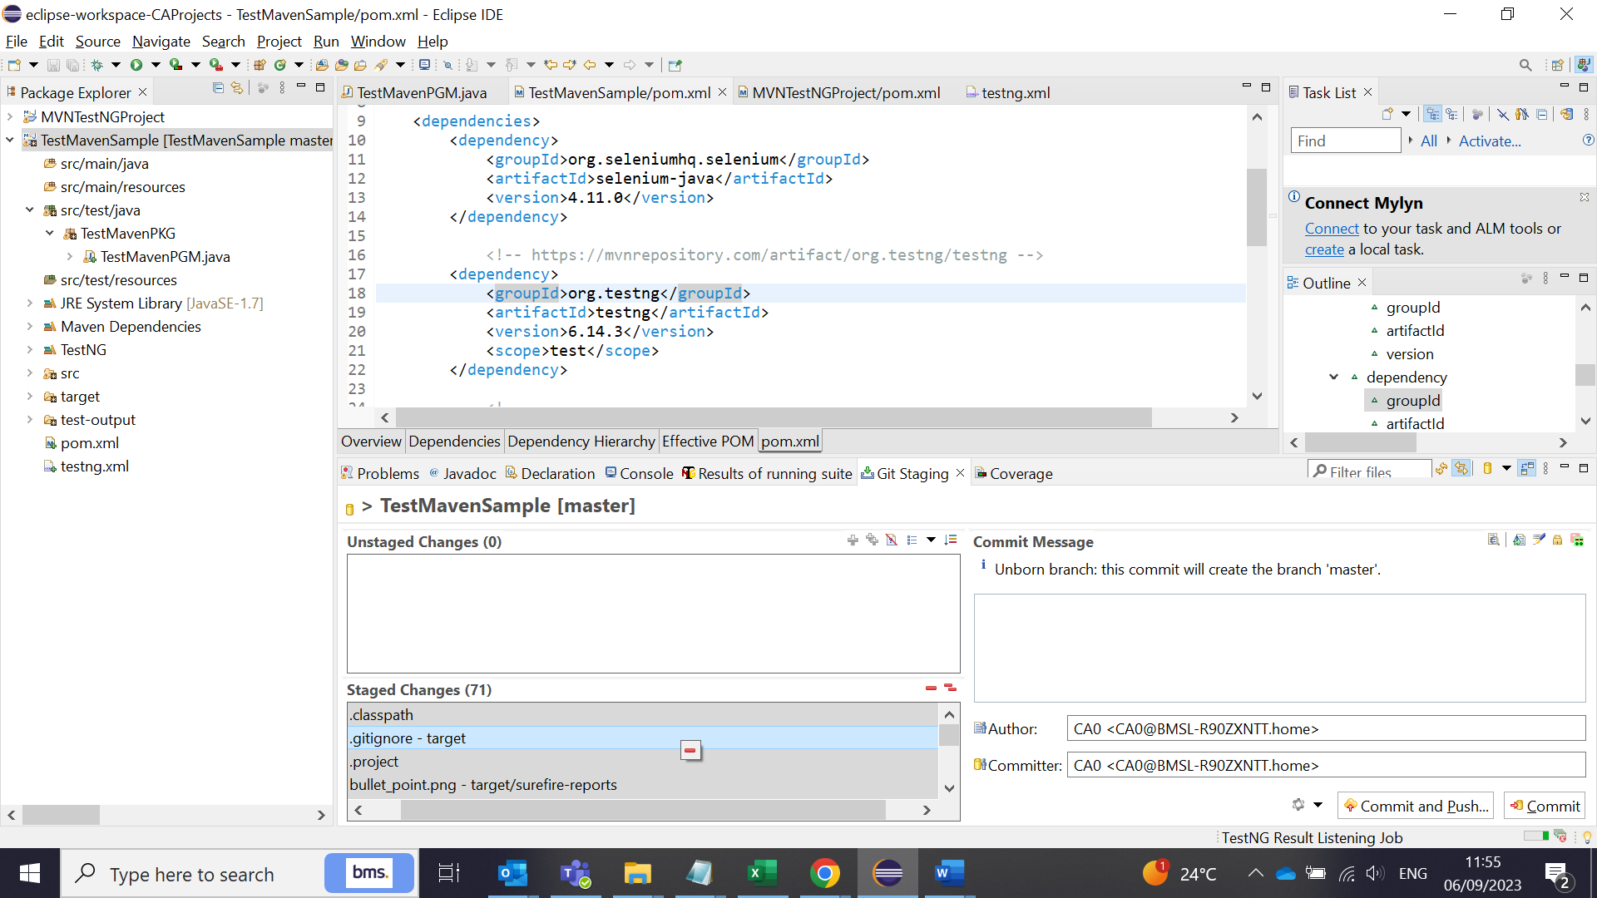

Enter the commit message and click ‘commit and push’ . Error wil come if the repository is not connected. Clcik OK. And then click ‘Push head’ button again.

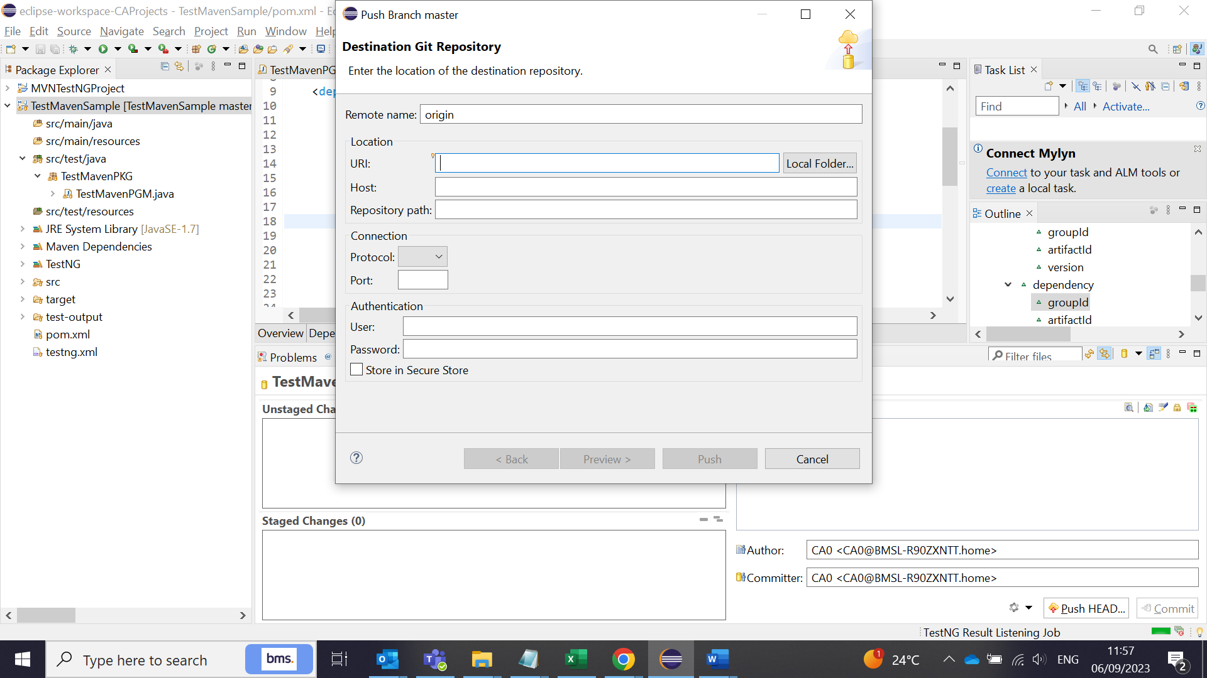

Enter the git hib newly created repsoity URL and enter username and password. Sometimes, the username and the password doesn’t work. In that case, generate a token (personal access token) in git hub under your accounts ->settings->Developer mode-> Classic token -> generate token. Copy the token generated in github website and paste in the password filed in Eclipse. It will accept it and the code will be pushed in to the **MASTER** branch of the repository.

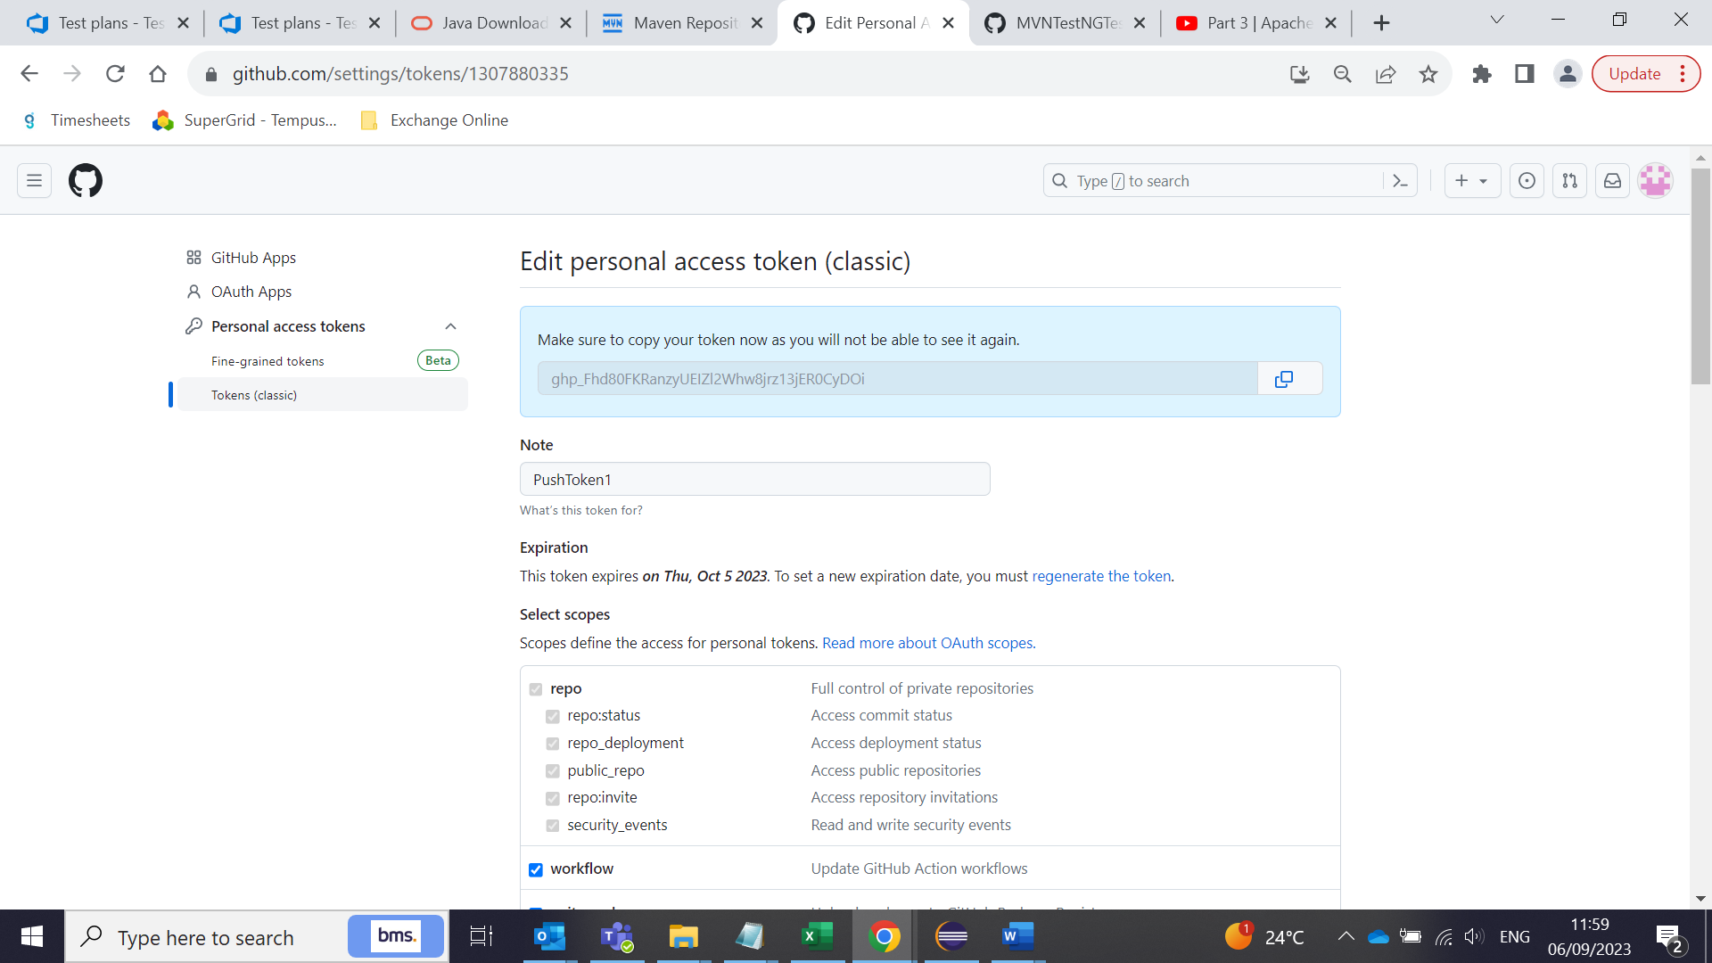

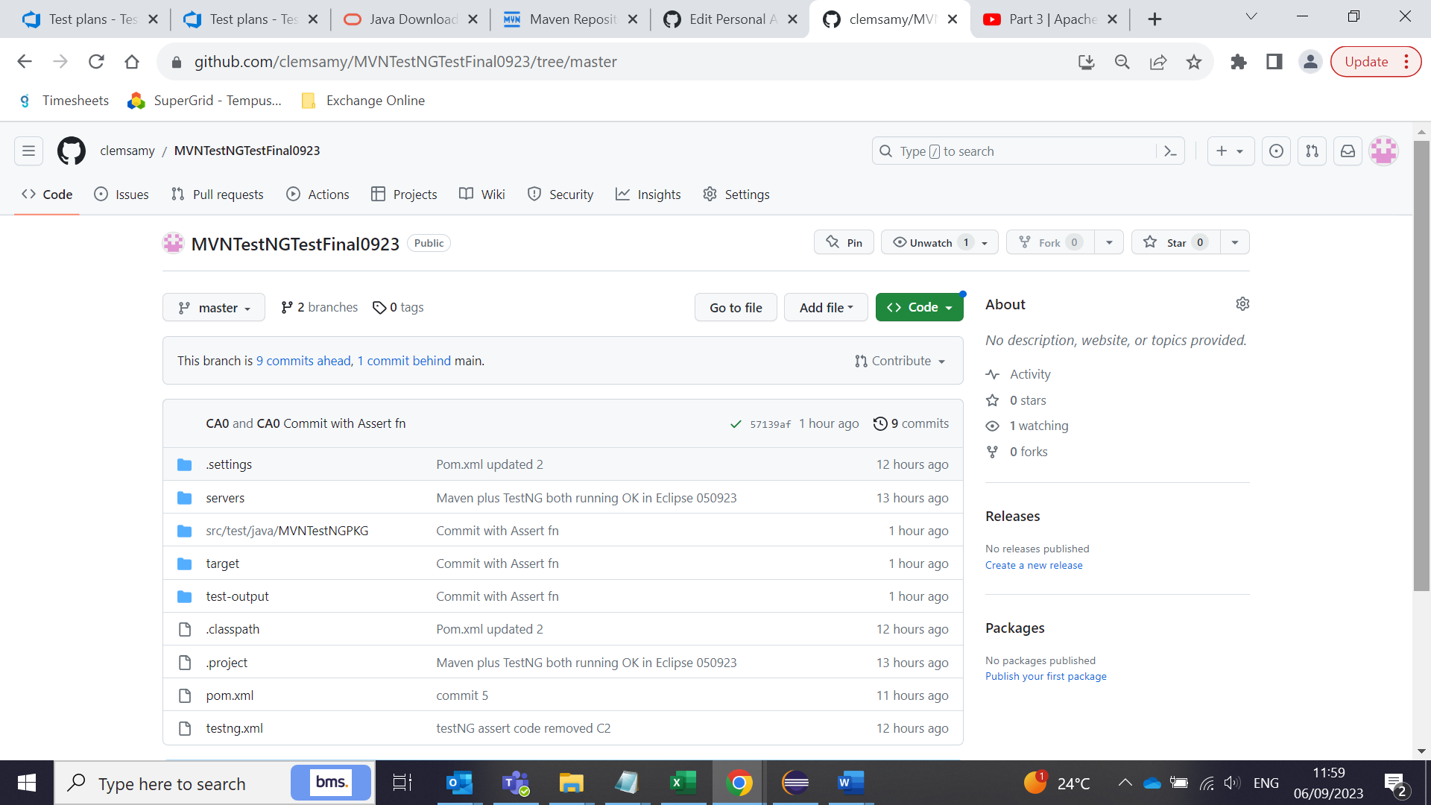

**How to connect GitHub and DevOps by creating a pipeline:**

Go to DevOps Pipeline tab:

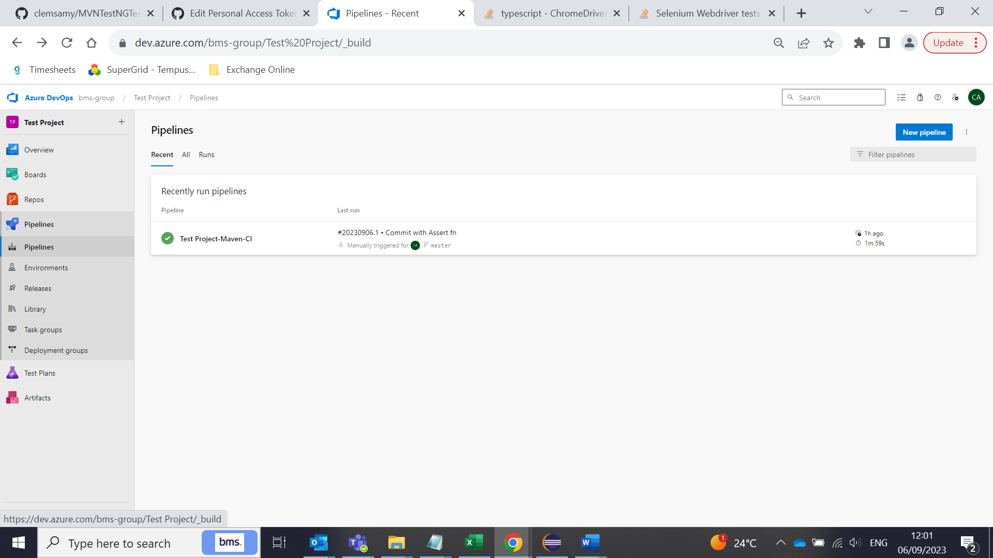

Create New pipeline:

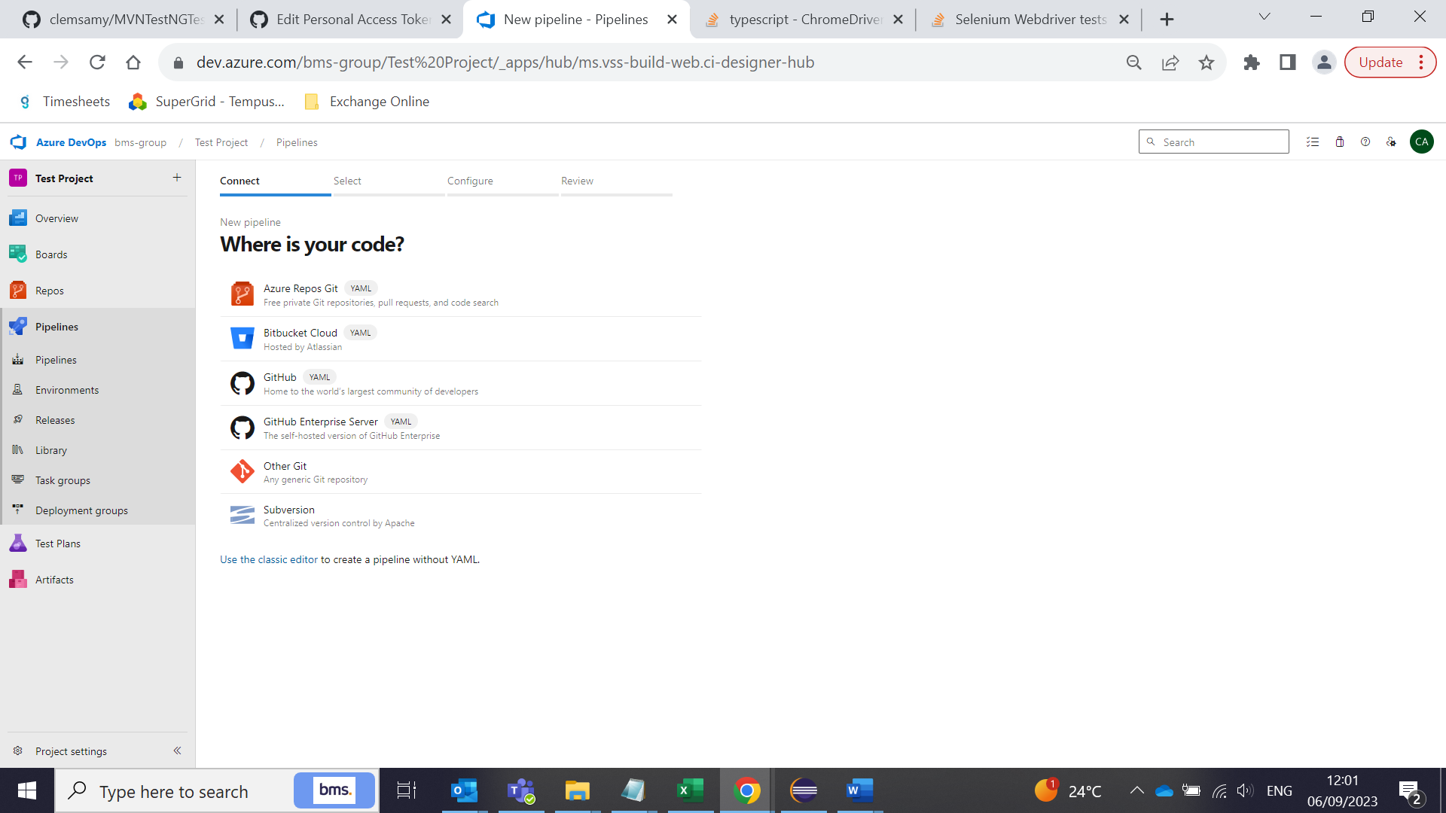

Click ‘Use classic editor’

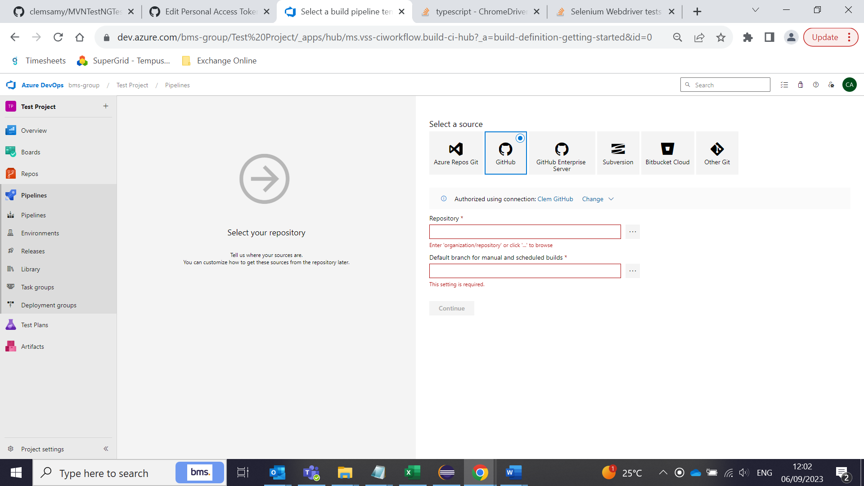

Select ‘Github’

First create a github repository connection using username and pawd or access token. Once connected, it will be looking like this:

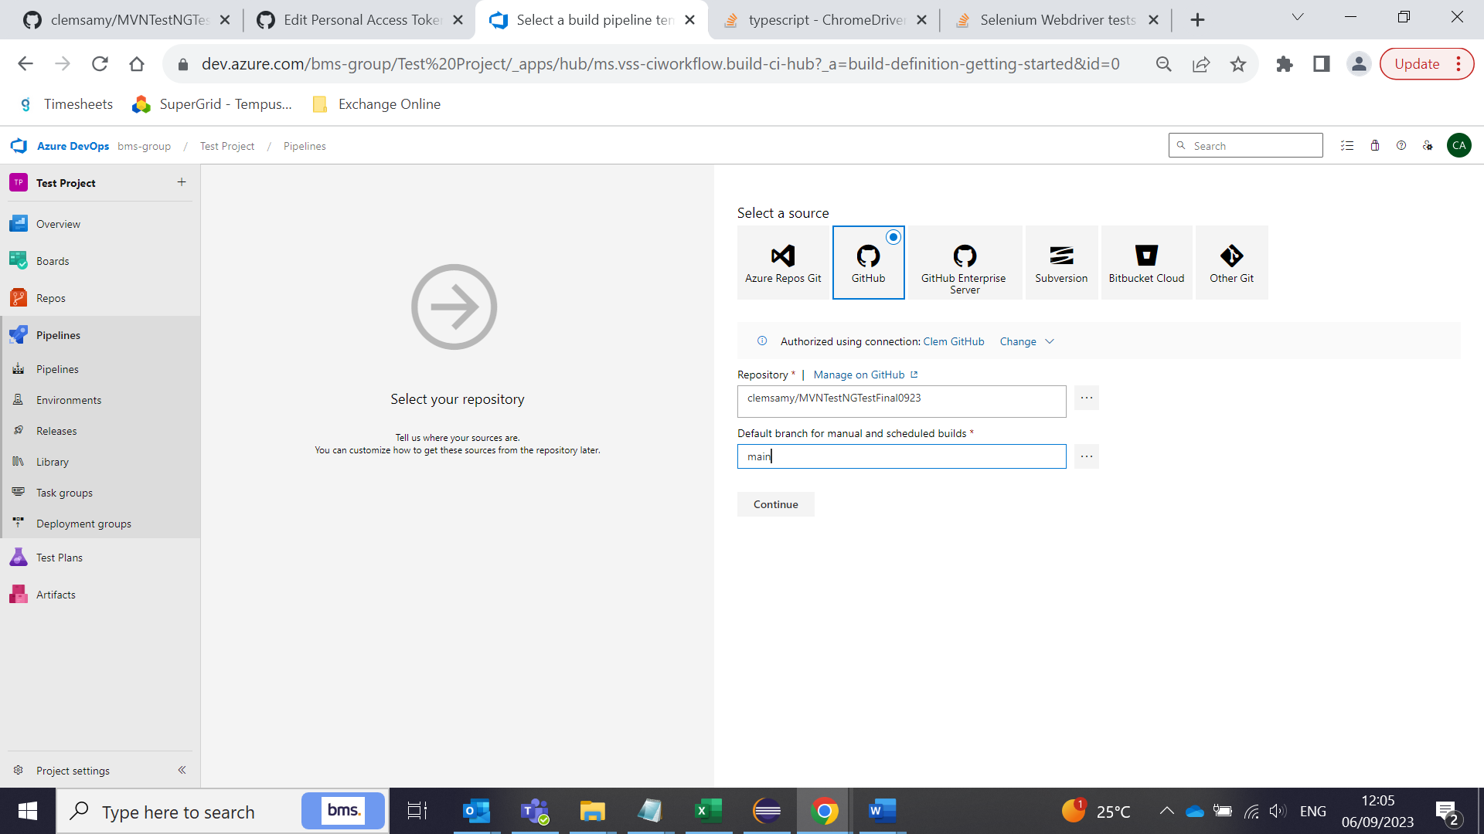

Select ‘Maven’ project

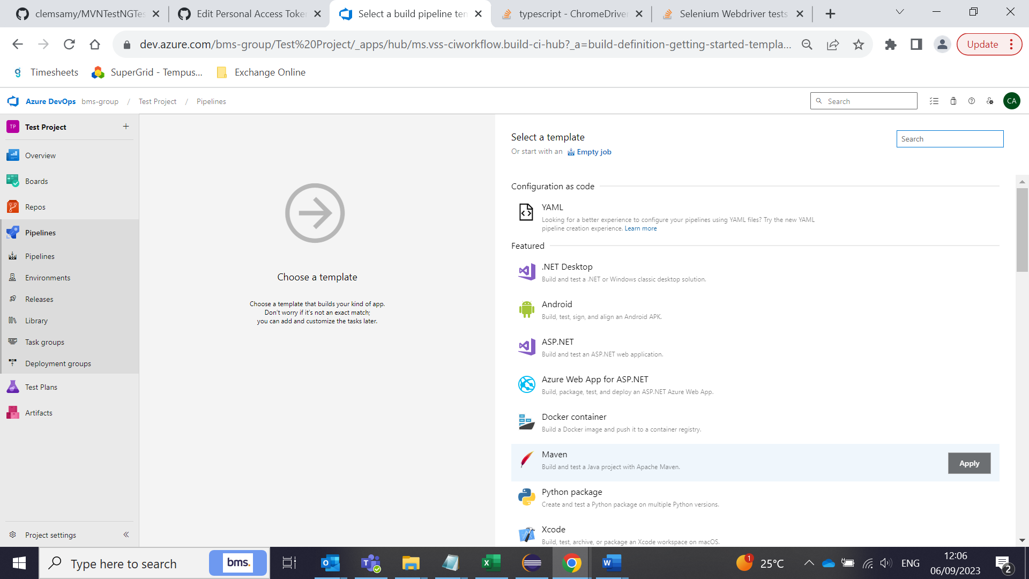

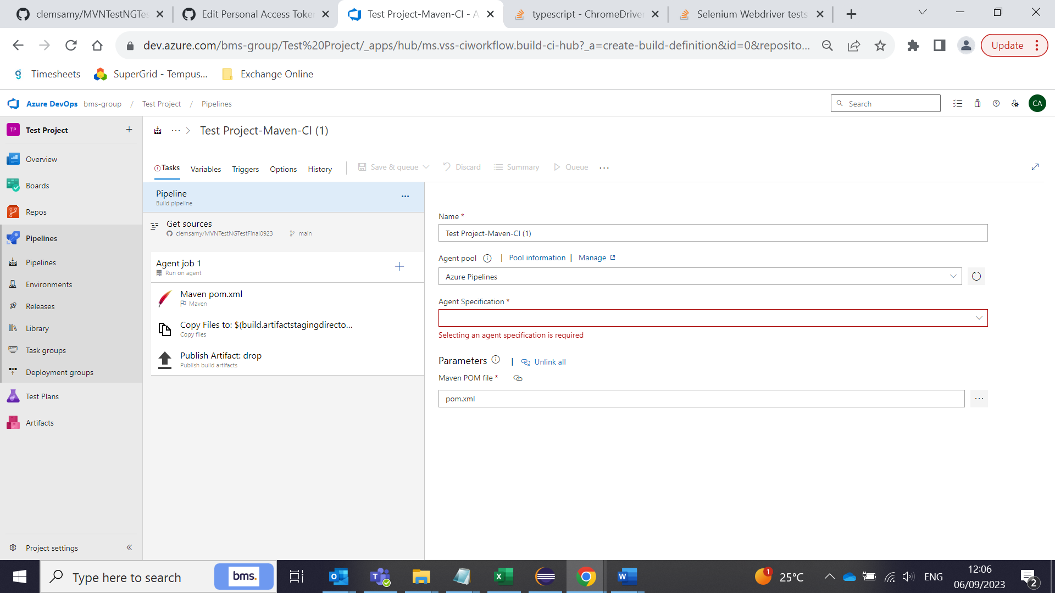

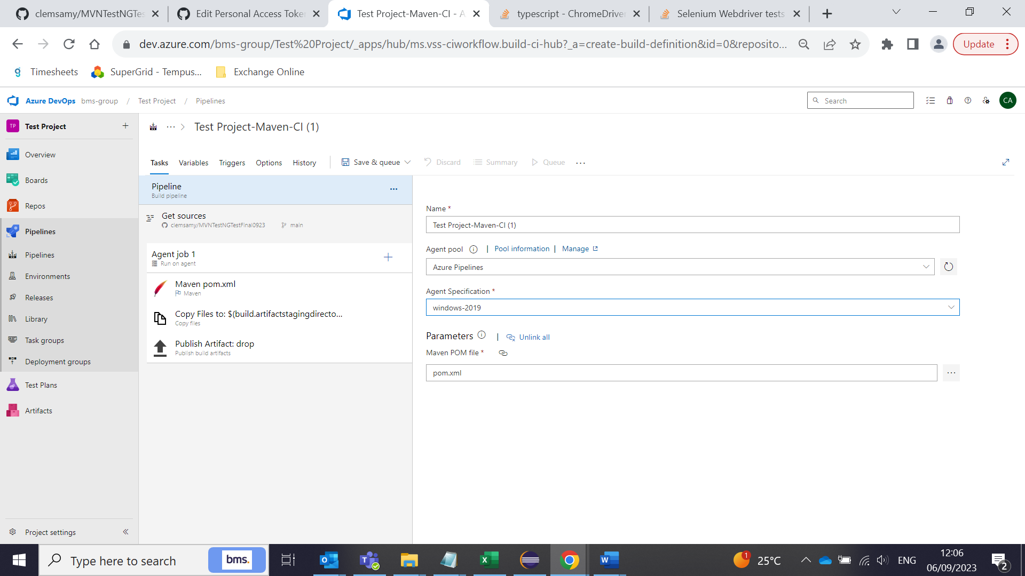

Once you selected the above environment and click on the Maven pom.xml on the left hand menu only, the Save&queue option will be enabled.

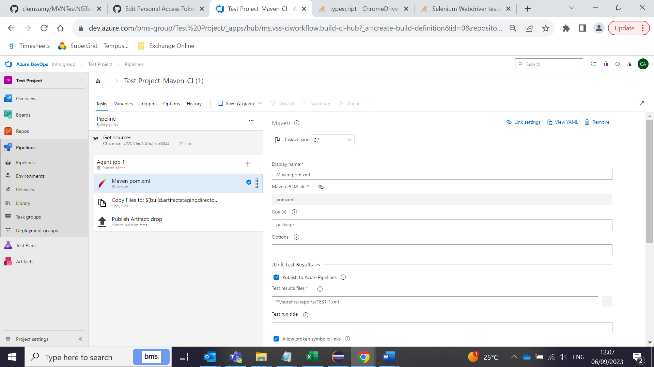

Enter ‘clean install’ in the goals:

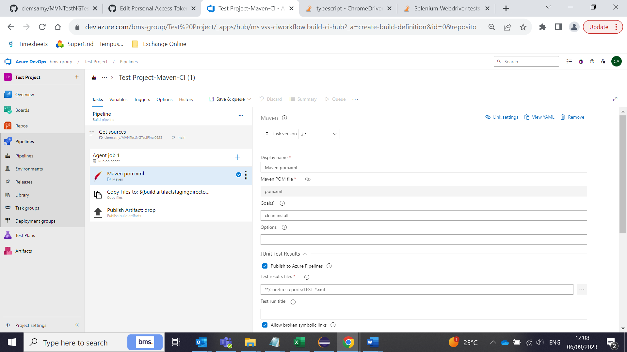

Click save & quue. Pipeline will be created.

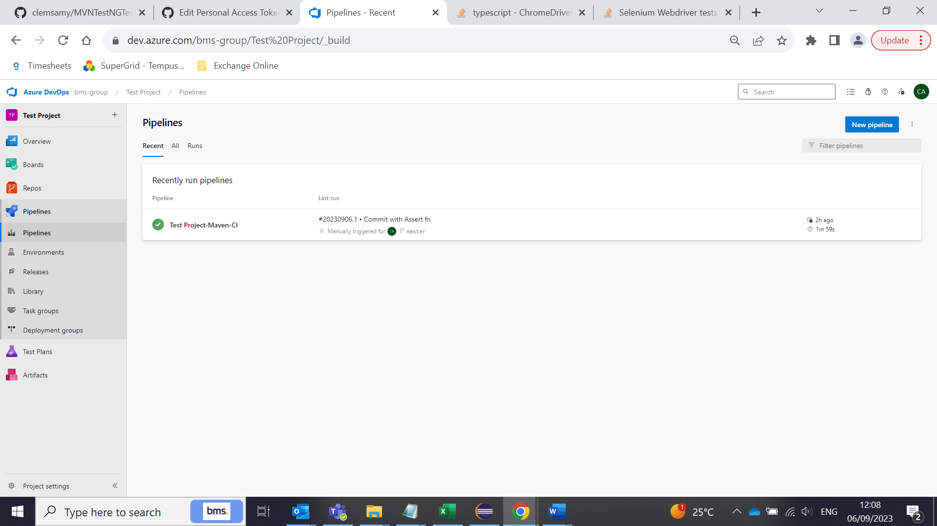

Select the pipeline created.

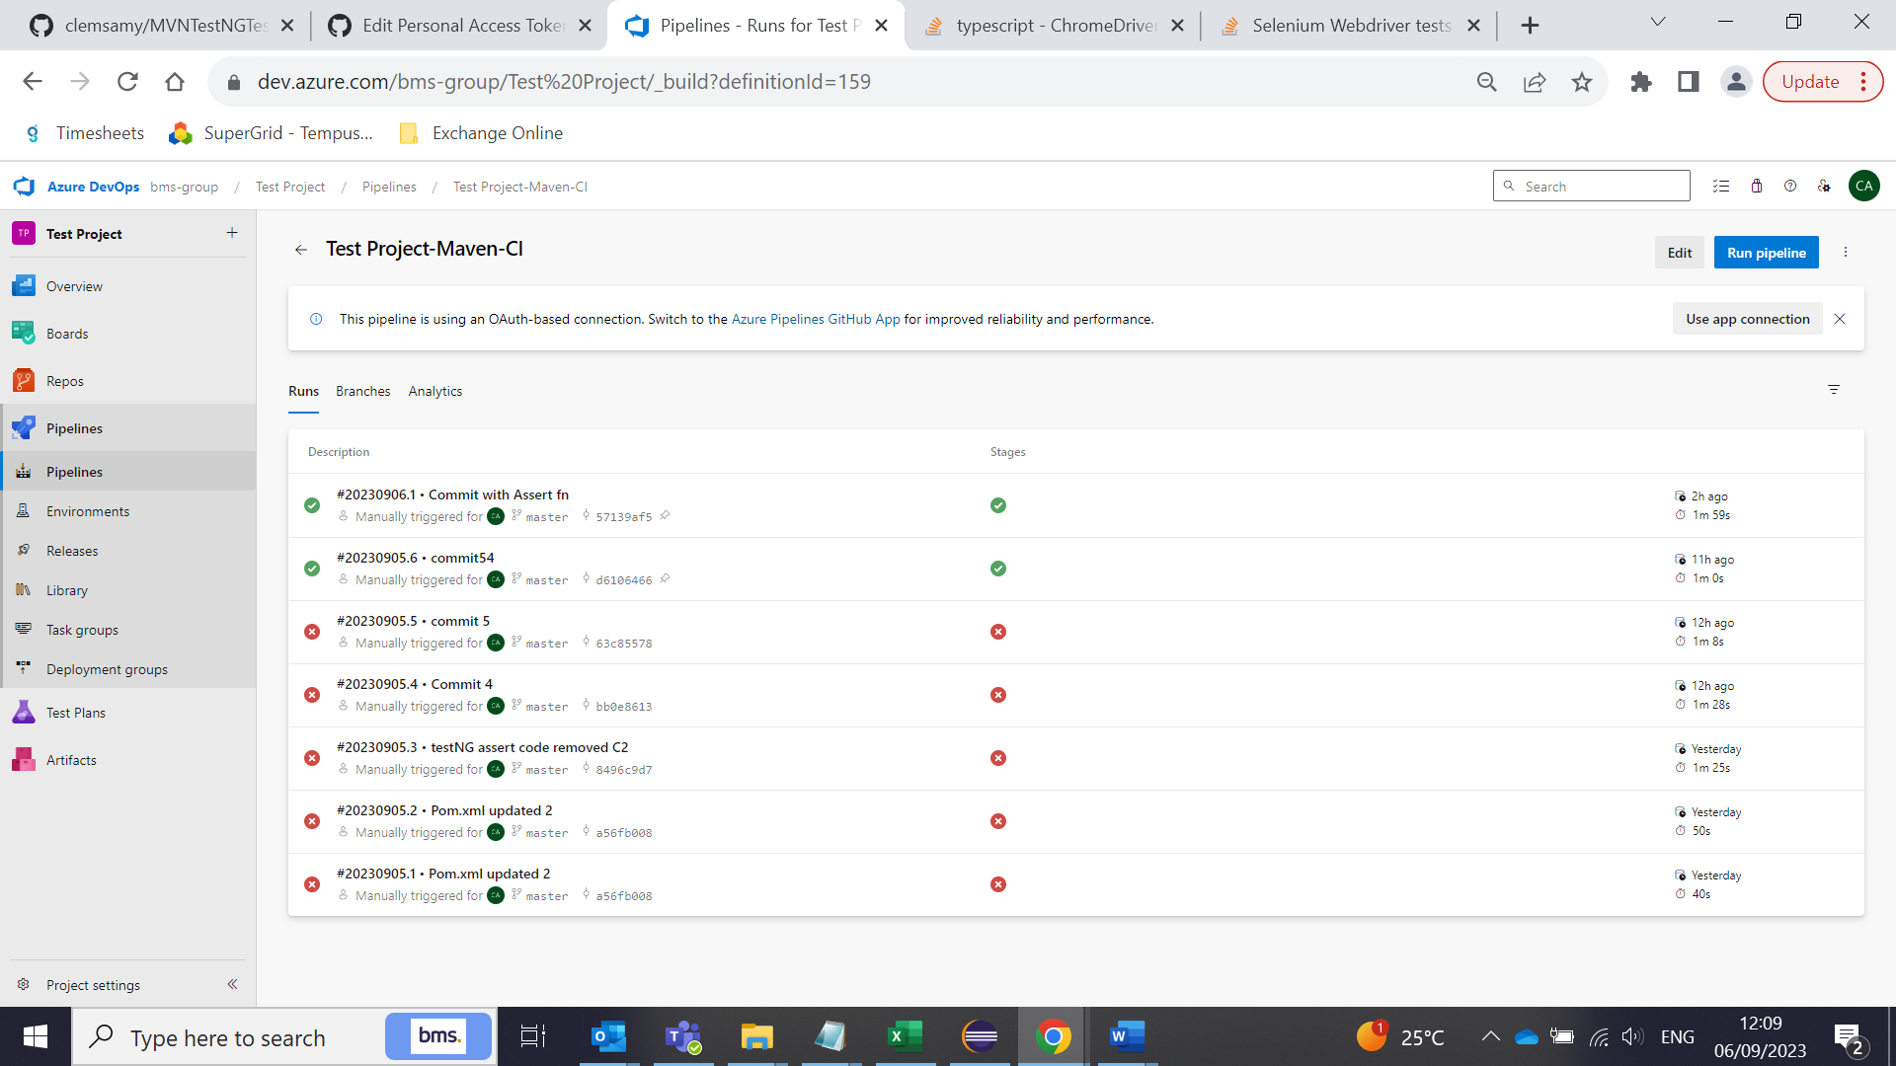

Click ‘Run Pipeline’

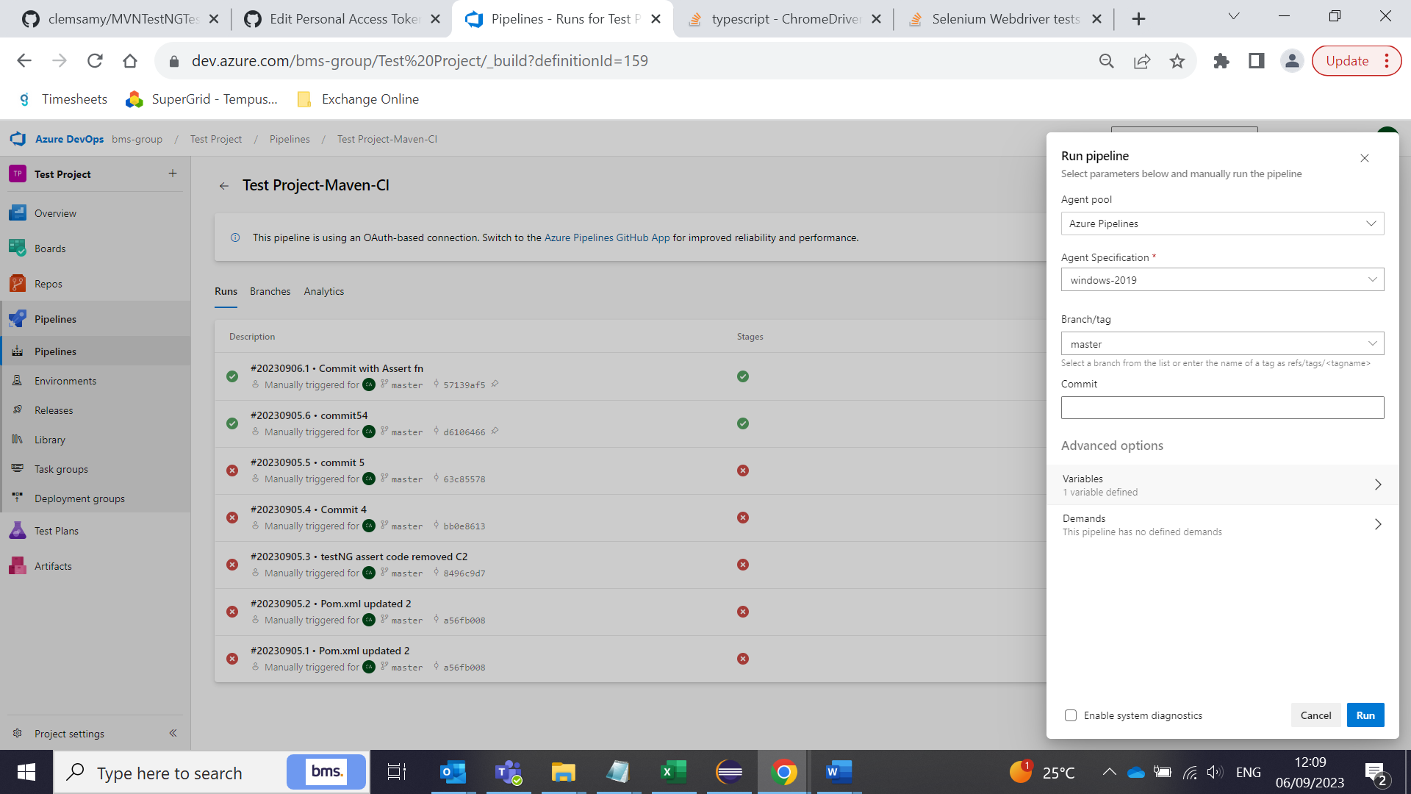

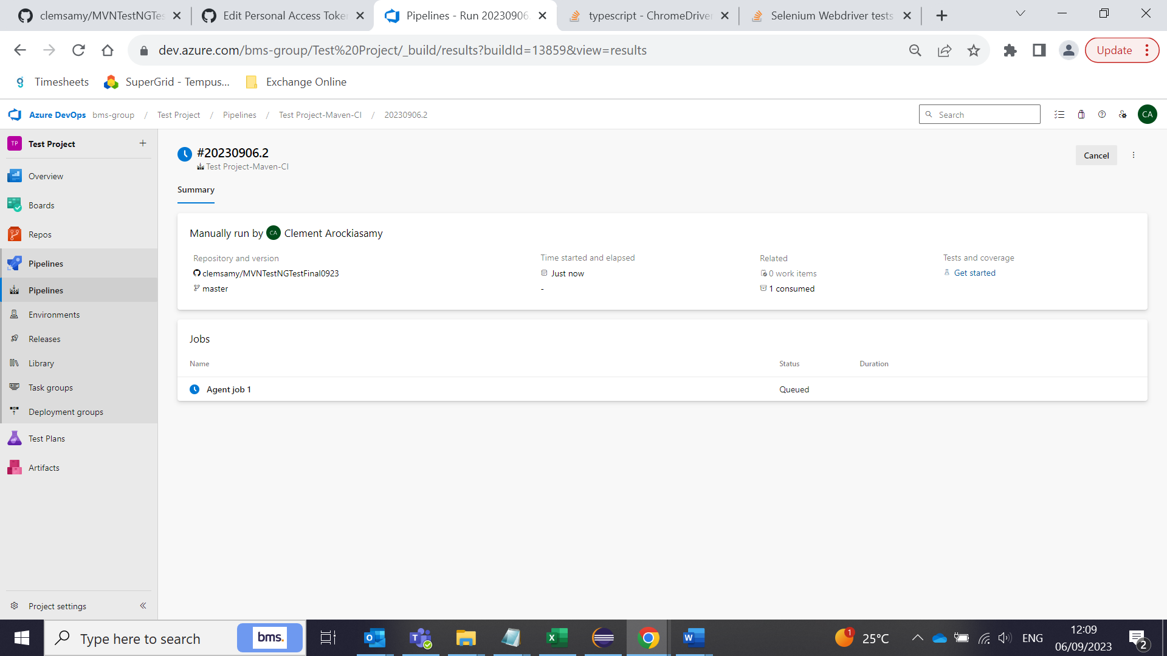

Select the agent job:

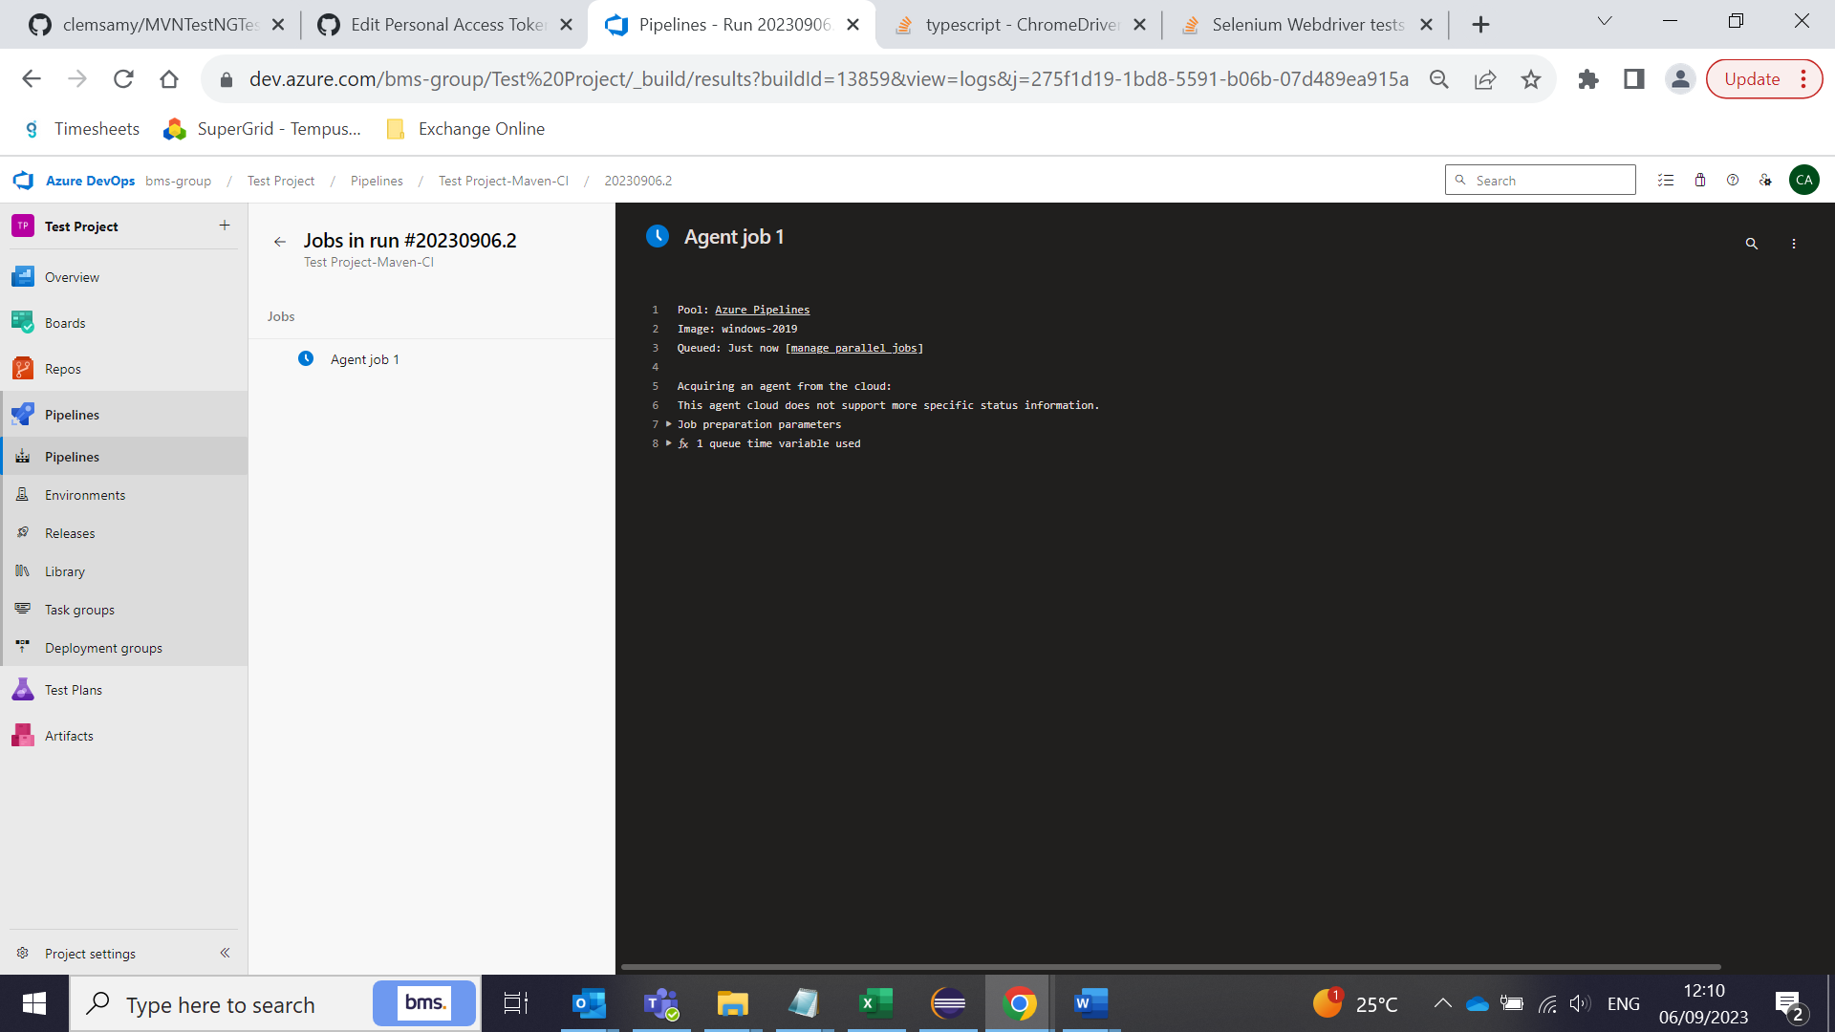

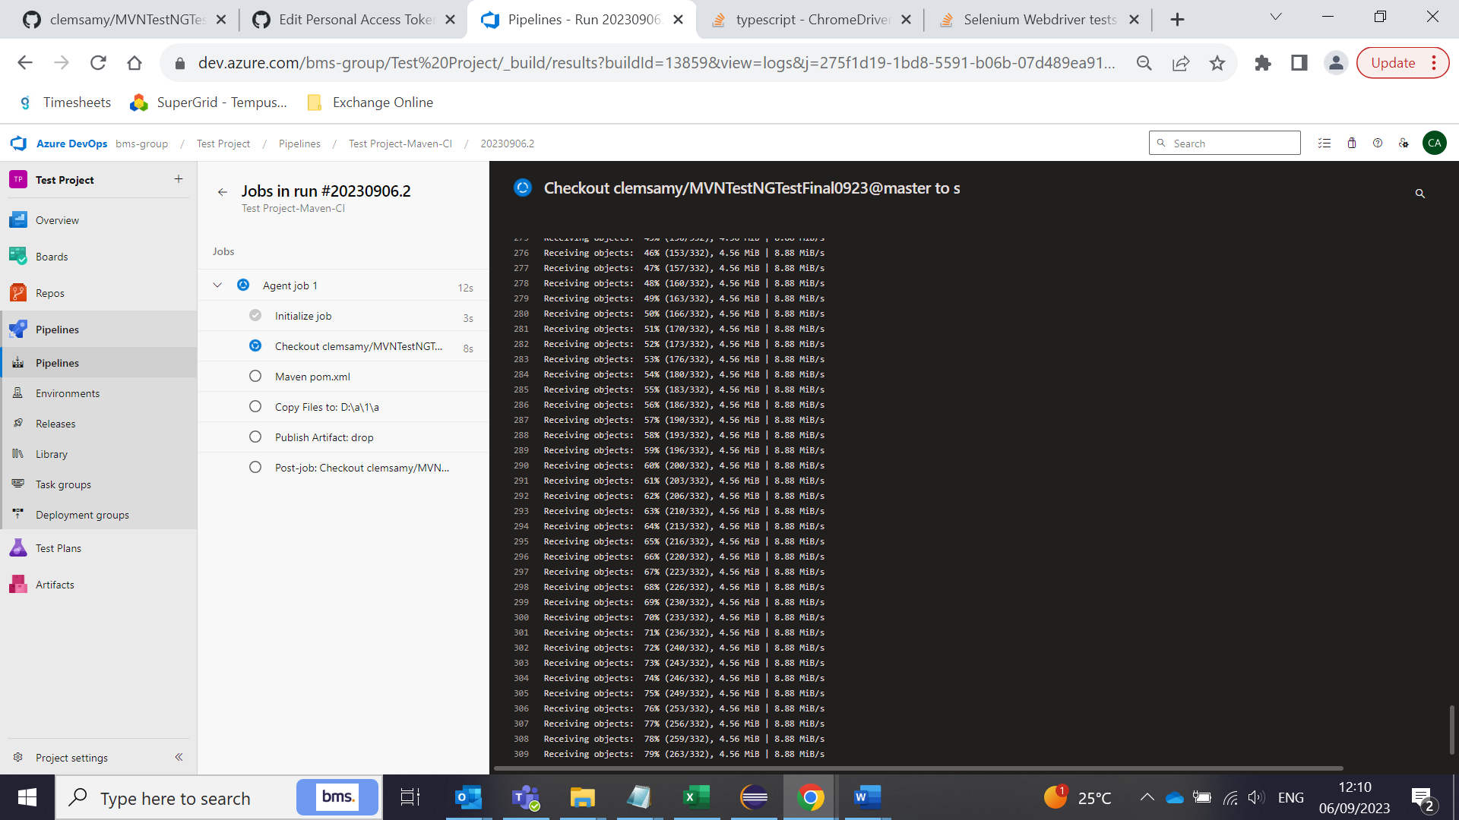

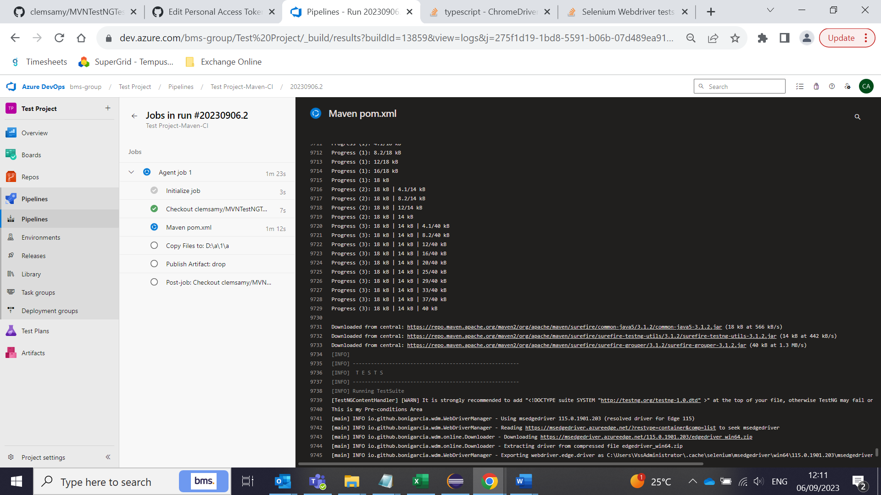

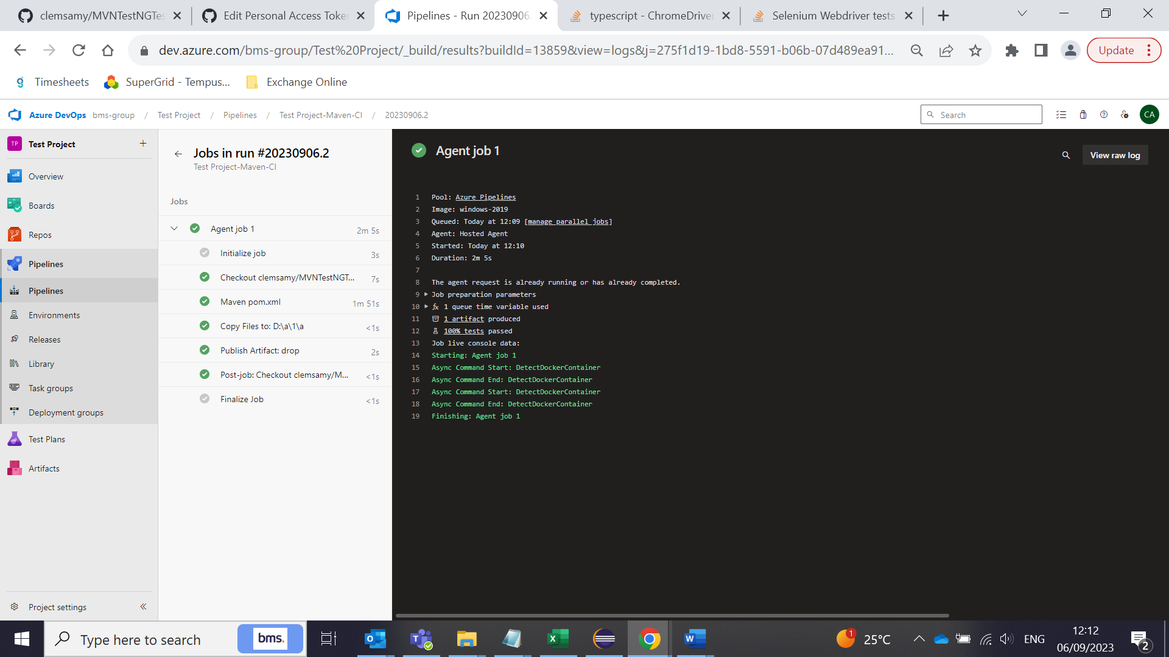

All the steps will be executed and will be in GREEN as above.

To see the test results, go back to the previous screen by clicking the back arrow in the jobs.

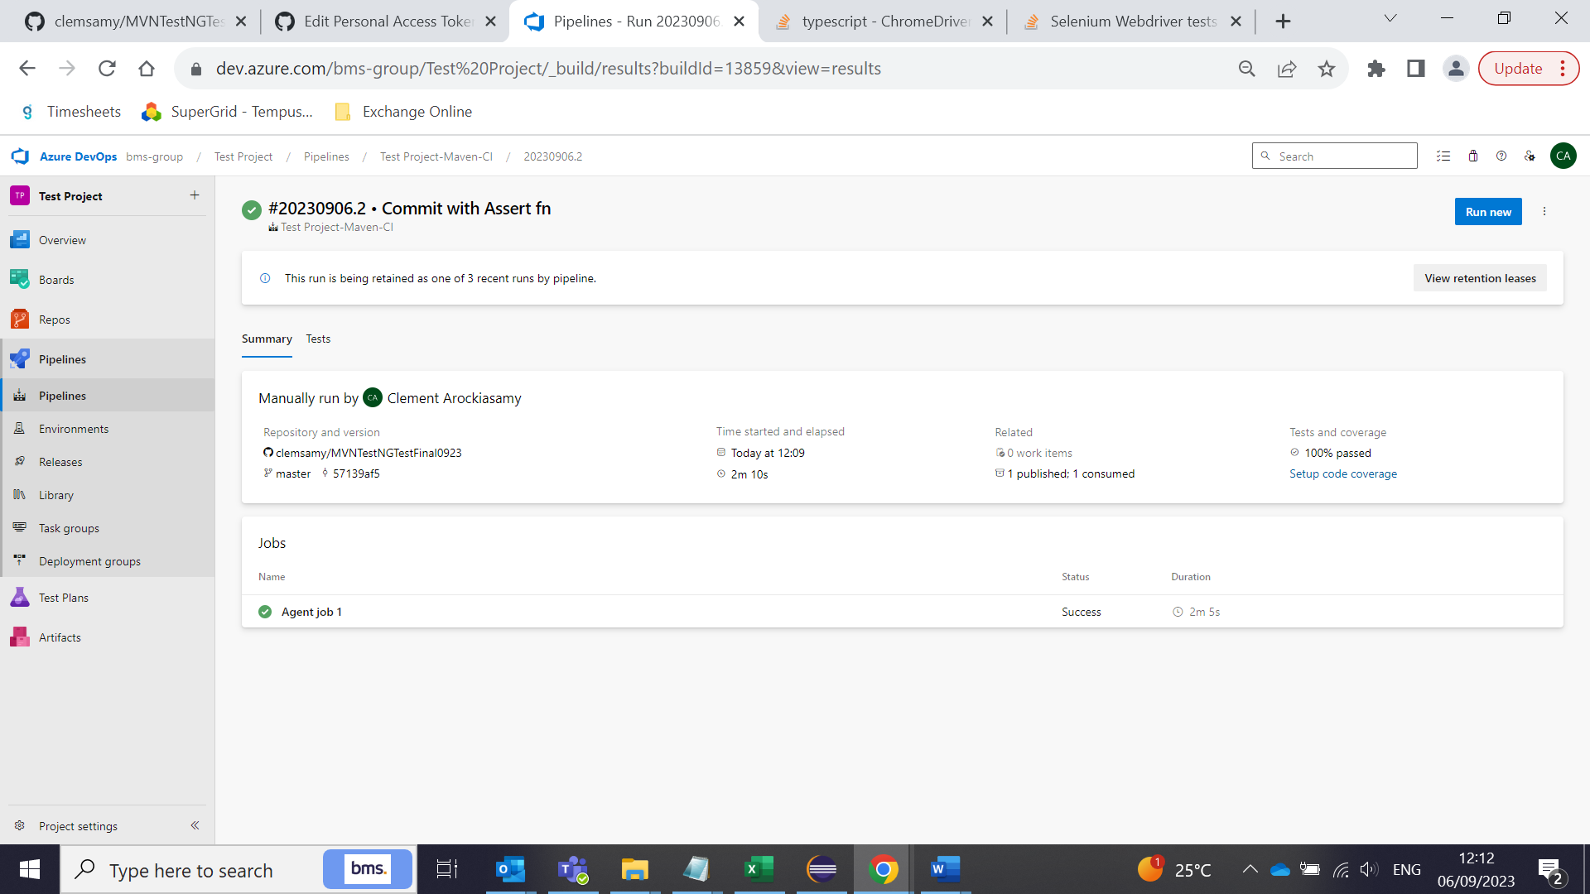

Select ‘Tests’ tab and you will see the results:

